|  |  |
| --- | --- |
| cetlogo ***CHEMICAL ENGINEERING TRANSACTIONS***  ***VOL. 92, 2022*** | A publication of  aidiclogo_grande |
| The Italian Association  of Chemical Engineering  Online at www.cetjournal.it |
| Guest Editors: Rubens Maciel Filho, Eliseo Ranzi, Leonardo Tognotti  Copyright © 2022, AIDIC Servizi S.r.l. **ISBN** 978-88-95608-90-7; **ISSN** 2283-9216 | |

Environmental evaluation of microalgae-based biodiesel production via in-situ transesterification

Ángel Darío González-Delgadoa\*, Aury S. Álvarez-Corderoa, Yuranis P. De Ávila-Alvisa

aNanomaterials and Computer-Aided Process Engineering Research Group (NIPAC), Chemical Engineering Department, Faculty of Engineering, University of Cartagena, Cartagena 130015, Colombia

corresponding.agonzalezd1@unicartagena.edu.co

A wide variety of biofuel feedstocks are investigated as viable alternatives to traditional fuels, including microalgae, which show strong advantages mainly due to its high growth rate and high lipid content. Microalgae-based biodiesel can substitute diesel in automobiles with little or no modification to vehicle engines. Therefore, extensive research is being advanced in the search for improvements in the biodiesel processing steps that will advance the commercial viability of microalgae-based biofuels. This work evaluates the environmental performance of biodiesel production from microalgae following the in-situ transesterification route. The process was initially modeled based on data reported in the literature, simulated using aspen plus software, and environmentally evaluated following the waste reduction algorithm (WAR). The environmental assessment provided the results for the potential environmental impact (PEI) output and generated for the process and the classification of the environmental impacts under 8 categories. The output rate of PEI was estimated at 1.31E+00 PEI/kg of product indicating that the waste streams have low environmental impact potential. Also, it was found that microalgae-based biodiesel production does not generate environmental impacts since raw materials with higher impact potential concerning the products are consumed. The categories of global warming potential and ozone depletion potential are not affected by this process.

* 1. Introduction

Accelerated population growth has led to an increase in the energy needs of the planet, which has driven up the consumption of fossil fuels as the main source of energy. The potential role of biofuels in addressing energy challenges has received significant attention from scientists from various disciplines and countries (Azadi et al., 2017), contributing to the development of new technologies for large-scale biofuel production. The scientific interest in biofuels lies in their potential to reduce the consumption of fossil resources and the precipitous increase in atmospheric greenhouse gas levels. A wide variety of biofuel feedstocks have been investigated as viable alternatives to traditional fuels including microalgae, which show strong advantages to biodiesel production (Rodolfi et al., 2009), including the high growth rate, efficient photosynthesis process, and bio-mass productivity (Yin et al., 2020).

Nowadays, Microalgae-based biodiesel is one of the most attractive fuels; it is an alternative, renewable, biodegradable, and environmentally friendly biofuel for transportation, with similar properties to petroleum-derived diesel, and can be used directly in a compression-ignition engine without requiring any modifications (Ali et al., 2017). However, several barriers in theory, techniques, and industrialization remain, leading to the high cost of biofuel from this biomass (Su et al., 2017). These barriers increase the importance of detailed research into the new emerging technologies forward from microalgae. In this work, the environmental analysis of microalgae-based biodiesel production via in-situ transesterification is evaluated. There are different methodologies, tools, and techniques to develop an environmental analysis of processes including the waste reduction algorithm (WAR), the Method of Environmental Impact Minimization (MEIM), the Life Cycle Analysis (LCA), the Tool for the Reduction and Assessment of Chemical and other environmental impacts (TRACI), among others. The WAR algorithm offers mainly the advantage of identifying how fast an environmental impact could be in the environment (Herrera-Aristizábal et al., 2017), moreover, not requiring a large quantity of information and can be performed through WARGUI, a free and accessible software.

* 1. Materials and methods

The methodology followed for the environmental assessment of the emerging microalgae-based topology for biodiesel production is described as follows: The process modeling is performed using information reported in the literature such as processing stages, operating conditions, and conversion of chemical reactions. The process data obtained in the modeling step is used to simulate the topology through the Aspen Plus software. Finally, the environmental performance of the process is evaluated using WARGUI software, which requires the mass and energy balances obtained in the simulation step.

* + 1. Process modeling

The block diagram for the production of microalgae-based biodiesel from microalgae via in-situ transesterification is shown in Figure 1. A stream of microalgae and nutrients at environmental conditions are fed to the process at the culture stage. Next, the microalgae are harvested by centrifugation and subjected to a drying process. The dried microalgae are sent to the transesterification stage where the reaction of the fatty acids and triglycerides contained in the microalgae with methanol in the presence of an acid catalyst occurs to produce methyl esters (biodiesel) and glycerol. Methanol and catalyst are added at a molar ratio of methanol: lipids 12:1 (Musa, 2016) and catalyst: lipids 1:1 (Ehimen Ehiaze, 2010), respectively. The mainstream is sent to a neutralization process while the microalgae cake is removed from the process. In the neutralization stage, CaO is added to neutralize the sulfuric acid; the calcium sulfate (CaSO4) obtained is discarded. Then, the neutralized stream passes to the methanol recovery unit; the separated methanol is sent to the transesterification stage and the methanol-free stream goes to the washing unit. In this stage, the water removes the glycerol allowing the separation of the biodiesel. Finally, the biodiesel and glycerol are purified and obtained as pure products.



Figure 1. Block diagram of microalgae-based biodiesel production via in-situ transesterification

* + 1. Process Simulation

The simulation of the microalgae-based biodiesel production via in-situ transesterification was carried out using Aspen Plus Software. The first for the simulation consists of selecting from the software database the chemical substances involved in the processes; in this case, all the substances were available. Then, the thermodynamic model and the equation of state are selected; the appropriate choice of these must guarantee the correct estimation of the physicochemical properties of the chemical substances. Finally, all process data, processing steps, operating conditions, raw material flows, chemical reactions are entered (Do et al., 2014). The microalgae used in this study was *Chlorella vulgaris*. The information reported by (Peralta-Ruiz et al., 2013) and (Piemonte, et al., 2016) were taken into account in the simulation of the microalgae. Fatty acid concentration of the microalgae is shown in Table 1.

Table 1: Fatty acid concentration of the microalgae.

|  |  |  |  |  |  |  |  |
| --- | --- | --- | --- | --- | --- | --- | --- |
| **Fatty acid** | **Myristic** | **Palmistic** |  | **Stearic** | **Oleic** | **Linoleic** | **Linolenic** |
| Composition (%) | 9 | 46 |  | 1 | 5 | 20 | 19 |

* + 1. Environmental assessment

The environmental assessment is used to determine the possible environmental impacts of a present or future industrial activity with the potential to cause ecological imbalance or exceed the limits established in the provisions for ecosystem protection (Pardo- Cardenas et al., 2013). The Waste Reduction Algorithm (WAR) is a methodology developed to evaluate and quantify the output and generated potential environmental impact (PEI) of industrial processes. Also, it allows the evaluation of PEI under eight impact categories: human toxicity potential by ingestion (HTPI), human toxicity potential by inhalation or dermal exposure (HTPE), aquatic toxicity potential (ATP), terrestrial toxicity potential (TTP), ozone depletion potential (ODP), global warming potential (GWP), photochemical oxidation potential (PCOP) or smog formation, and acidification potential (AP). The output PEI measures the impact emitted by the process to its surroundings, while the generated PEI allows determining the internal environmental efficiency of the process, in other words, the amount of environmental impact that is being consumed or generated. Both indicators can be calculated per unit of time or mass as shown in equations 1-4.

|  |  |
| --- | --- |
|  | (1) |
|  | (2) |
|  | (3) |
|  | (4) |

* 1. Results and discussion

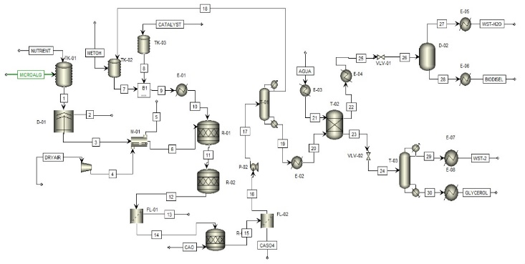

Figure 2. Simulation of microalgae-based biodiesel production via in-situ transesterification

Figure 2 shows the simulation performed for the microalgae-based biodiesel production by the in-situ transesterification method. The microalgae stream and a nutrient stream are fed to the culture stage (TK-01). Next, the mainstream is sent to the centrifuge D-01 where the microalgae are harvested and a large amount of water is removed. To obtain a moisture content of 5%, the microalgae are subjected to a drying process with dry air entering at a temperature of 50°C. The dried microalgae stream (stream 6) is sent to the reactor R-01 where lipid extraction and transesterification occurs by the addition of methanol (stream 7) and catalyst (stream 8). From this stage, the microalgae cake (stream 13) is discarded while the biodiesel-rich stream (stream 14) is sent to the reactor R-03 where CaO is added to neutralize the catalyst; from this stage, calcium sulfate (stream CASO4) is obtained as a residue. The neutralized stream (stream 16) is sent to the distillation tower T-01 to separate the methanol and recirculate it to the transesterification stage (stream 18). The stream containing the biodiesel and glycerol (stream 20) enters the washing unit T-02 along with a hot water stream. In this stage the biodiesel is separated, the glycerol is carried away by the water (stream 24) and sent to the distillation tower T-03 where pure glycerol is obtained at a rate of 127.25 kg/h. The biodiesel stream with small traces of water (co-stream 25) goes to the flash separator D-02 where it is obtained as a pure product in stream 28 at a rate of 208 kg/h. Information on the operating conditions and mass flow rates of the main process streams are summarized in Table 2.

Table 2. Operating conditions of the main streams of microalgae-based biodiesel production via in-situ transesterification

|  |  |  |  |  |  |  |  |  |  |
| --- | --- | --- | --- | --- | --- | --- | --- | --- | --- |
| **Stream** | **Microalg** | **Nutrie** | **3** | **6** | **14** | **16** | **19** | **Biodiesel** | **Glycerol** |
| T (°C) | 25.00 | 25.00 | 25.00 | 25.60 | 60.00 | 70.00 | 99.53 | 30.00 | 30.00 |
| P (bar) | 1.01 | 1.01 | 1.01 | 1.01 | 1.01 | 1.01 | 1.01 | 0.10 | 0.70 |
| Mass flow (kg/h) | 1,000 | 9,000 | 1,057.9 | 998 | 2,025.0 | 1,840.7 | 368 | 223.1 | 127.3 |

The environmental analysis for the microalgae-based biodiesel production was carried out using WarGUI software, taking into account the following considerations:

* The fuel used as an energy source was natural gas due to being the least polluting concerning coal and oil (Alvarez et al., 2017).
* The energy required in the processes was estimated at 20,518.63 MJ/h.

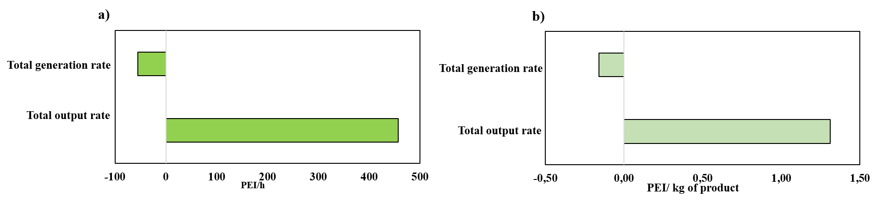Figure 3 shows the environmental performance of the production of microalgae-based biodiesel via in-situ transesterification. The process achieves negative values for the generated impacts (-55.5 PEI/h and -0.16 PEI/g of product), which indicates that the process consumes environmental impacts since there is a transformation of high impact raw materials such as methanol and sulfuric acid mainly into products with lower environmental impact such as biodiesel and glycerol. Regarding the total PEI emission rate, lower values are obtained in comparison with the production of other biofuels such as bioethanol from palm rachis (Arteaga et al., 2018) or the dual production of biodiesel and hydrogen in a combined biorefinery of palm and Jatropha biomass (Ninõ-Villalobos et al., 2020). The PEI emission rate is estimated at 1.31 PEI/ kg of biodiesel and glycerol to produce 223.1 kg of biodiesel and 127.3 kg of glycerol; these values suggest that the process is environmentally efficient.

Figure 3. Total environmental performance of microalgae-based biodiesel production via in-situ transesterification a) PEI per unit of time, b) PEI per unit of mass

The output and generated toxicological impacts for biodiesel production from microalgae are shown in Figure 4. Human toxicity by ingestion (HTPI) and terrestrial toxicity (TTP) reach the highest estimates for PEI production and generation, which is mainly due to the output of trace amounts of sulfuric acid and hexane. Due to nature of fatty acids and high boiling point, they have minor atmospheric environmental impacts. Regarding toxicological impacts, they contribute significatively to increase output environmental impacts. Furthermore, these substances are used in alimentary and comestic industry (Archambault & Bonté, 2021) , which means that most of the fatty acids are safe to humans. The results for the HTPE category were estimated at 26.60 PEI/h, which shows that the substances emitted do not represent a dermal exposure hazard to the human population. Concerning the aquatic toxicity potential (ATP) category, values of 1.11 PEI/h were estimated, indicating that the process is less harmful to aquatic ecosystems. The values reached for the PEI generated were negative for all categories indicating that the products leaving the process are less toxic than the input streams; the methanol recovery stage reduces the amount of effluent, therefore the process is environmentally efficient from a toxicological viewpoint (Marticorena et al., 2010).

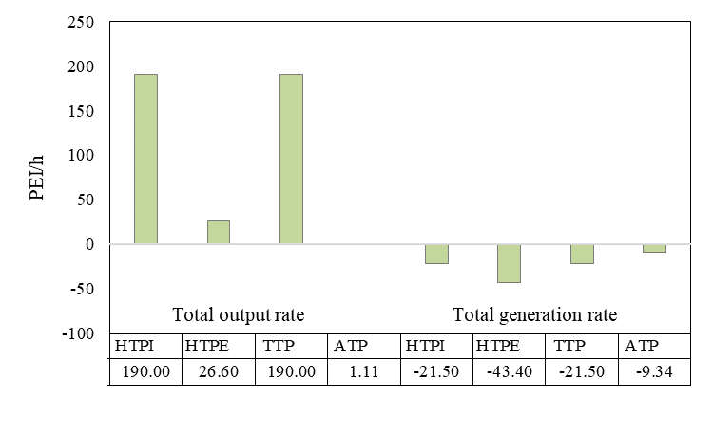

Figure 4. Toxicological impacts of microalgae-based biodiesel production via in-situ transesterification.

Figure 5 shows the atmospheric impacts emitted and generated through the system. The ozone depletion potential (ODP) and global warming potential (GWP) categories were estimated not to contribute significantly to the emission impacts compared to the other categories. The photochemical oxidation potential (PCOP) category represents the highest contribution to the atmospheric impacts emitted which is attributed to the output of biofuels and smog-generating substances. On the other hand, the impact output under the category of acidification potential is associated with the sulfuric acid used as a catalyst, therefore, it is recommended to consider the use of alternative ecological catalysts, taking into account that an alkaline catalyst cannot be used as saponification reaction may be carried out because of the high content of free fatty acids. Some authors have proposed the use of hydrochloric acid as catalyst of transesterification of microalgae (Kim et al., 2015), however hydrochloric acid have a higher acidification potencial than sulfuric acid, as well as HTPI and TTP. Regarding PEI generated, positive values were obtained for all categories of atmospheric impact, indicating that the products obtained have a higher potential for atmospheric impact than the raw materials.

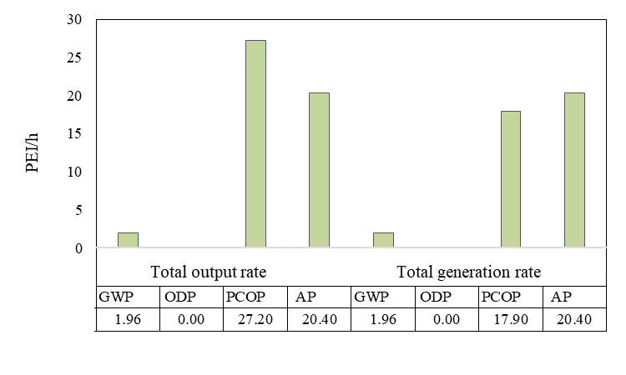

Figure 5. Atmospherical impacts of microalgae-based biodiesel production via in-situ transesterification.

* 1. Conclusions

In this study, the environmental performance of microalgae-based biodiesel production via in-situ transesterification was modeled, simulated, and evaluated. The process was modeled for processing 1000 kg/h of microalgae and simulated using Aspen Plus software. The output rate of PEI was estimated at 1.31E+00 PEI/kg of product indicating that the waste streams have low environmental impact potential compared to a palm-based biorefinery whose PEI output rate was calculated about 3E+00 PEI/kg (Herrera-Aristizabal et. al., 2017). Also, it was found that microalgae-based biodiesel production generates negative potencial environmental impacts taking into account that raw materials present higher potential environmental impacts than the products obtained. The category of ozone depletion potential is not affected by this process since the process does not regenerate CFC’s.

Acknowledgments

We would like to express our sincere gratitude to Universidad de Cartagena (Colombia) for providing the equipment and software to conclude this research.

References

Ali M., Sultana R., Tahir, S., Watson I. A., Saleem, M., 2017, Prospects of microalgal biodiesel production in Pakistan – A review, Renewable, and Sustainable Energy Reviews, 80, 1588–1596.

Alvarez A., De Avila Y., González-Delgado A. D., Ortiz, M, 2017. Environmental Assessment of Dual Crude Palm and Kernel Oil Production in Noth-Colombia using WAR Algorithm, Journal of Engineering and Applied Sciences, 12, 7265–7271.

Archambault J., Bonté F., 2021, Vegetable Fats In Cosmeticology, Revista boliviana de química, 38, 68 – 79.

Arteaga S., Sanjuan M., González-Delgado A, 2018, Computer-Aided Environmental Evaluation of Bioethanol Production from Empty Palm Fruit Bunches using Oxalic Acid Pretreatment and Molecular Sieves, Chemical Engineering Transactions, 70, 2113–2118.

Azadi P., Malina R., Barrett S. R. H., Kraft M, 2017, The evolution of the biofuel science. Renewable and Sustainable Energy Reviews, 76(October 2016), 1479–1484. https://doi.org/10.1016/j.rser.2016.11.181

Do, T. X., Lim, Y. Il, & Yeo, H. (2014). Techno-economic analysis of bio-oil production process from palm empty fruit bunches, Energy Conversion and Management, 80, 525–534.

Ehimen Ehiaze, A, 2010, An investigation on the co-production of biodiesel and methane from microalgae, University of Otago.

Herrera-Aristizábal R., Salgado-Dueñas J. S., Peralta-Ruiz Y., González-Delgado A, 2017, Environmental Evaluation of a Palm-based biorefinery under North-Colombian Conditions, Chemical Engineering Transactions, 57, 193–198.

Kim B., Hanjin I., Lee J. W., 2015, In situ transesterification of highly wet microalgae using hydrochloric acid, Bioresource Technology, 185, 421-425.

Marticorena A. A., Mandagarán B. A., Campanella E. A, 2010, Análisis del impacto ambiental de la recuperación de metanol en la producción de biodiesel usando el algoritmo de reducción de desechos WAR., Informacion Tecnologica, 21, 23–30.

Musa I. A, 2016, The effects of alcohol to oil molar ratios and the type of alcohol on biodiesel production using transesterification process, Egyptian Journal of Petroleum, 25, 21–31.

Ninõ-Villalobos A., Puello-Yarce J., González-Delgado Á. D., Ojeda K. A., Sánchez-Tuirán E, 2020, Biodiesel and Hydrogen Production in a Combined Palm and Jatropha Biomass Biorefinery: Simulation, Techno-Economic, and Environmental Evaluation, ACS Omega, 5, 7074–7084.

Pardo- Cardenas, Y., Herrera- Orozco, I., González- Delgado, A. D., & Kafarov, V., 2013, Enviromental Assessment of Microalgae Biosiesel Production in Colombia: Comparison of Three oil Extraction Systems. Latinoamerican Journal of Oil & Gas and Alternative Energy, 5, 85–100.

Peralta-Ruiz, Y., González-Delgado, A.-D., Kafarov, V., 2013, Evaluation of alternatives for microalgae oil extraction based on exergy analysis, Applied Energy, 101, 226–236.

Piemonte, V., Di, L., Iaquaniello, G., Prisciandaro, M., 2016, Biodiesel production from microalgae : ionic liquid process simulation, Journal of Cleaner Production, 111, 62–68

Rodolfi L., Zittelli G. C., Bassi N., Padovani G., Biondi N., Bonini G., Tredici M. R, 2009, Microalgae for oil: Strain selection, induction of lipid synthesis and outdoor mass cultivation in a low-cost photobioreactor, Biotechnology and Bioengineering, 102, 100–112.

Su Y., Song K., Zhang P., Su Y., Cheng J., Chen X, 2017, Progress of microalgae biofuel’s commercialization, Renewable and Sustainable Energy Reviews, 74, 402–411.

Yin Z., Zhu L., Li S., Hu T., Chu R., Mo F., Hu D., Liu C., Li B, 2020, A comprehensive review on cultivation and harvesting of microalgae for biodiesel production: Environmental pollution control and future directions, Bioresource Technology, 301, 122804.